Brief Note on Impact of GST 2.0 Rate Changes on Rajasthan GST Revenue (FY 2025-26)
The rate rationalization carried out under GST 2.0 represents an important reform initiative aimed at simplifying the tax structure, improving affordability for consumers, and promoting sectoral growth. The State Government fully supports these reform objectives. However, a preliminary assessment undertaken by this Department indicates that Rajasthan has experienced an estimated GST revenue shortfall of approximately ₹2,050 crore during the period 22 September 2025 to 31 March 2026 following implementation of the revised rate structure.
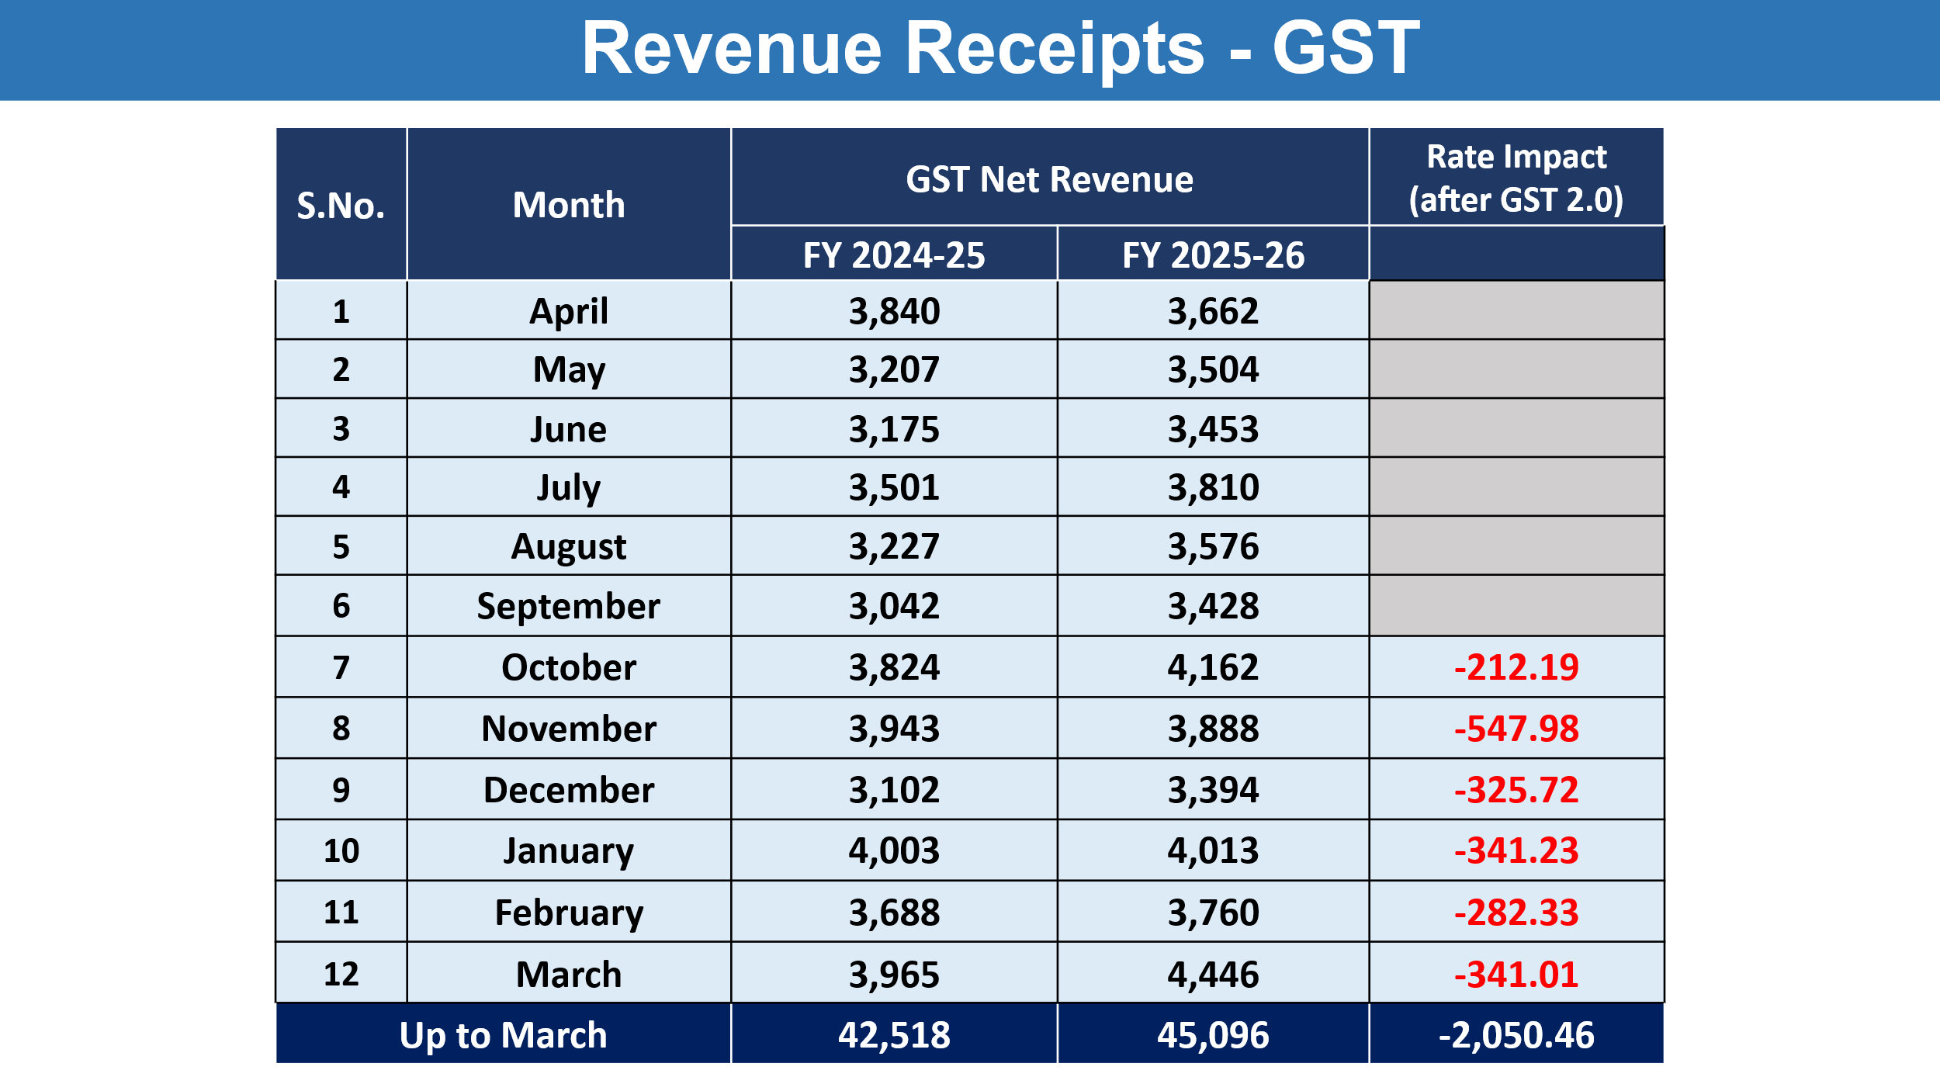
The revenue impact has been particularly significant in sectors which historically constitute the core of Rajasthan’s GST base. The State’s revenue profile is substantially dependent upon infrastructure-linked and consumption-driven sectors such as cement, automobile trade, pharmaceuticals, insurance services, and solar/renewable energy.
Rajasthan, while being a major cement-producing State, functions largely as a consuming State under the destination-based GST framework. Earlier placement of cement and allied products in higher GST slabs ensured substantial SGST accruals. The reduction in tax rates has resulted in compression of effective tax realization despite stable or rising consumption levels.
Similarly, rationalization of GST rates in the automobile and pharmaceutical sectors, along with reductions applicable to rubber products and related goods, has lowered tax incidence at the dealer level. While these measures are expected to stimulate demand over the medium term, the immediate fiscal impact has been adverse, leading to a measurable decline in monthly revenue accruals.
In the solar and renewable energy sector, reduced GST rates combined with higher utilisation of accumulated Input Tax Credit (ITC) have significantly lowered effective tax payments and ITC reversals, further contributing to revenue contraction.
The cumulative effect across these sectors has resulted in an estimated revenue loss of about ₹2,050 crore in FY 2025-26 (post 22 September 2025).

Key Observations
- Rajasthan GST Net Revenue increased from ₹42,518 Crore in FY 2024-25 to ₹45,096 Crore in FY 2025-26, reflecting an overall growth of approximately 6.07%.
- After adjusting the estimated impact of GST 2.0 rate reductions, the effective growth would have been approximately 11%, indicating a substantial revenue compression due to rate rationalization.
- The adverse impact became visible from October 2025 onwards, after implementation of revised GST rates under GST 2.0.

Major Sectors Contributing to Revenue Reduction
Sector | Before GST 2.0 | After GST2.0 | New Rate  (GST 2.0) |  | Estimated based on |  | Difference
 |  |  |  |  | Old Rates
 | Old GST Rate | New GST Rate | Liability | Net Revenue | Liability | Net Revenue | Liability | Net Revenue
Vehicle/Automobile & Spare Parts | 28% | 18% | 12736.88 | 2487.43 | 18786.38 | 3148.35 | -6049.50 | -660.92
Electrical Equipment | 28% | 18% | 8836.51 | 1219.32 | 10976.92 | 1737.51 | -2140.41 | -518.19
Cement / Construction | 28% | 18% | 9609.02 | 1610.45 | 12194.64 | 2082.52 | -2585.62 | -472.07
Rubber & articles thereof | 18% | 5% | 998.66 | 198.45 | 1502.35 | 401.93 | -503.69 | -203.48
Insurance | 18% | 0% | 320.11 | 41.82 | 834.84 | 245.00 | -514.73 | -203.18
Heavy Machinery & Air Conditioning | 28% | 18% | 3801.62 | 358.13 | 4277.89 | 529.90 | -476.26 | -171.77
Pharmaceuticals | 5% 12% | 0% / 5% | 368.38 | 115.03 | 800.42 | 251.31 | -432.04 | -136.28
Edible Items  (Food Sector) | 5% / 12% | 0% / 5% | 759.30 | 124.43 | 1182.40 | 156.28 | -423.10 | -31.86
Total |  |  | 37430.48 | 6155.06 | 50555.82 | 8552.82 | -13125.34 | -2397.77

Offset Through Coal Sector
- The increase in GST rate on coal from 5% to 18% partially compensated for the revenue loss.
- The coal and power generation sector contributed an estimated additional revenue of approximately ₹347 Crore.

Top 10 Sector Analysis (FY 2024-25 vs FY 2025-26)
Sectors | Turnover  (FY 24-25) | Turnover  (FY 25-26) | Change% | Total Tax Payable  (FY 2024-25) | Total Tax Payable  (FY 2025-26) | Change % | Net Revenue  to State  (FY 24-25) | Net Revenue  to State  (FY 25-26) | Change %
Rate Reduced after GST 2.0
Vehicle/Automobile & Spare Parts | 90849 | 97850 | 8% | 22848 | 20567 | -10% | 5889 | 5702 | -3%
Electrical machinery and equipment | 101961 | 117105 | 15% | 16350 | 17168 | 5% | 3495 | 3591 | 3%
Machinery & Air Conditioning | 55822 | 58802 | 5% | 10023 | 10027 | 0% | 1951 | 1752 | -10%
Financial & Banking Services | 122963 | 130229 | 6% | 5476 | 5392 | -2% | 1647 | 1622 | -1%
Construction / Real Estate / Cement | 97459 | 89392 | -8% | 16019 | 14223 | -11% | 3582 | 3134 | -13%
No Change in Rates
Iron and steel | 69996 | 70216 | 0% | 12372 | 12440 | 1% | 2448 | 2368 | -3%
Plastics and articles thereof | 35368 | 36047 | 2% | 5918 | 6066 | 2% | 1119 | 1016 | -9%
Support services | 21393 | 24738 | 16% | 3277 | 3719 | 13% | 1204 | 1326 | 10%
Articles of iron or steel | 21542 | 22810 | 6% | 3685 | 3797 | 3% | 1002 | 1023 | 2%
Rate increased after GST 2.0
Fuel and Energy | 212639 | 210972 | -1% | 3987 | 4575 | 15% | 2312 | 2717 | 18%
All Sectors Total | 28,62,294 | 3,54,693 | 17% | 2,43,108 | 2,57,248 | 6% | 42518 | 45096 | 6%

Overall Assessment
The GST 2.0 reforms have resulted in reduction in tax burden across several consumer and industrial sectors, increased affordability and compliance simplification, but also a notable short-term reduction in State GST realization.
Despite the estimated revenue loss of around ₹2,050 Crore, Rajasthan has maintained positive GST growth during FY 2025-26 through improved compliance, economic activity, and administrative enforcement measures.
The analysis indicates that without GST 2.0 rate rationalization, Rajasthan’s GST revenue growth for FY 2025-26 would have been substantially higher.

